**FAIREMBO - Connection details**

**Pinout diagram :**

**Correspondences on the real card - relative pins on arduino :** 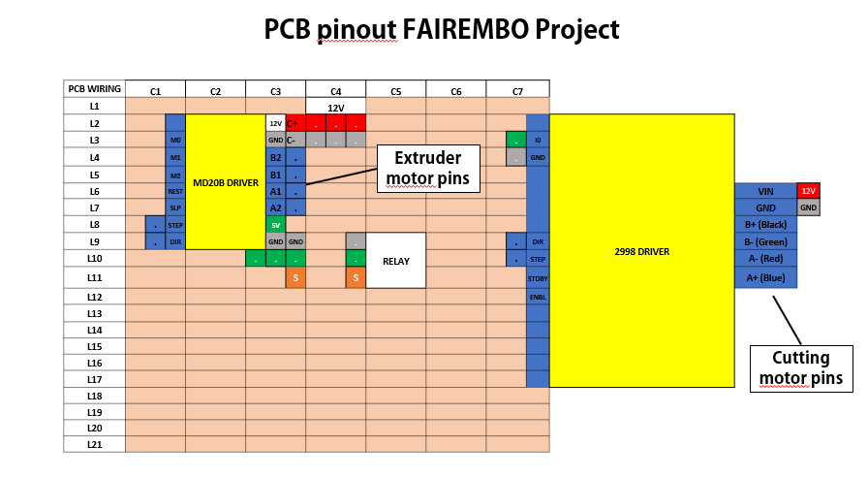

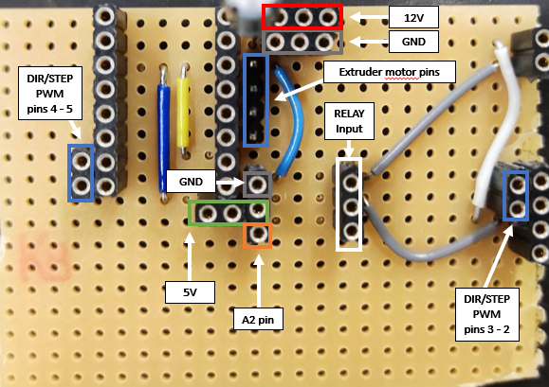

**Picture of the card with relay and drivers mounted on :**

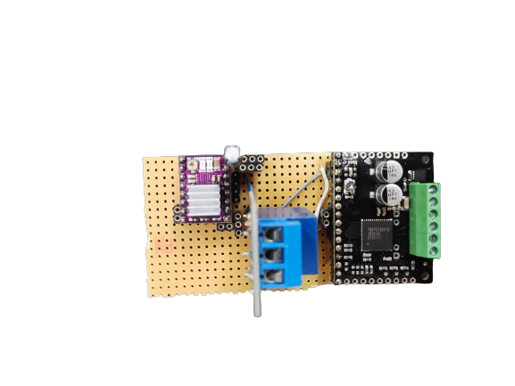

**Power wiring : (Note that ascending order of motor pin colors is always Blue - Red - Green - Black)**

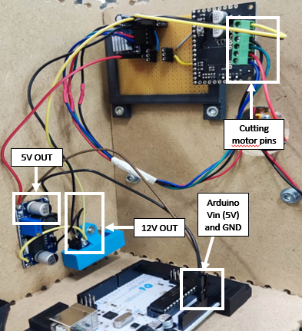

**Front panel details (and relative pins for arduino) :**

